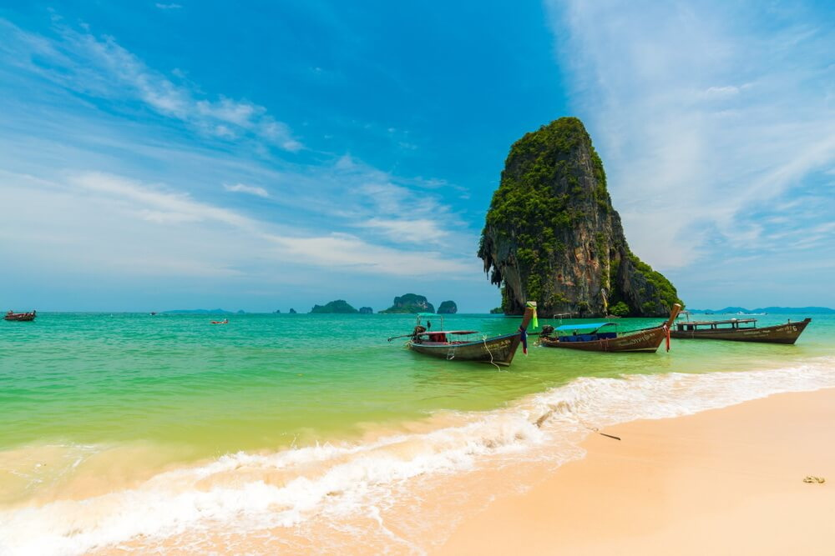
Krabi 4 Islands 1 Day Tour By Speed Boat
( Adult 900 Baht/Person Child 700 Baht/person )

Time: 09.00am. – 03.00 pm.
08.30 a.m : Pick up from the hotel
09.00 a.m : Depart Nopparat Thara Beach
Chicken Island : Sightseeing and enjoy swimming & snorkeling among coral reef and Fishes. Remember the name and you’ll remember its funny rock shape.
Tub Island : One of Thailand’s unseen Highlights. Relaxing the white sandy linkage between Tap Island and Chicken Island at low tide.
Poda Island : Relax for sunbathing and sea sports. Lovely white sandy beach ideal for sunbathing swimming and snorkeling.
Pranang Cave : Visit Phra Nang Cave to learn the history which is the sacred image for the local people, spectacular the stalagmite and the stalactite.
03.30 p.m. Arrive Ao nang Beach and Transfer back to hotel.

Tour Includes : Lunch, Snack, Fresh fruits, Soft drinks ,Life jacket, Snorkel equipment, Insurance and Experienced guide.
Tour Itinerary
Exclusions :
- Optional tours or excursions not mentioned in the program
- Other meals not mentioned in the program
- Personal expenses
- Services change 3.5% pay by credit cards
Remark : The company will take a right to change the program for suitable and also can be changed subjected to the weather without prior notice. This package only available on Wed, Fri and Sunday until November.

*PRICE AND ITINERARY ARE SUBJECT TO CHANGE WITHOUT PRIOR NOTICE*

