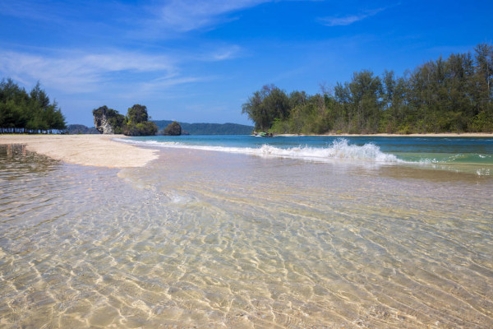
Krabi Premium 4 Islands 1 Day Tour
( Adult 1,200 Baht/Person Child 900 Baht/person )
Time: 09.15 am. – 03.00 pm.
- 09.15 - 09.45 a.m.: Pick up from the hotel.
- 10.30 a.m. : Depart from Nopparat Thara Beach.
* Chicken Island : Enjoy swimming & snorkeling among coral reef and Fishes.
* Si Island : Popular location for excellent snorkeling the marine life here will amaze .
* Tub Island : Relaxing the white sandy linkage between Tap Island and Chicken
Island at low tide.
* Poda Island : Relax for sunbathing and sea sports.
* Railay Beach : Lunch time at Restaurant at Railay Beach.
* Pranang Cave : Visit Phra Nang Cave to learn the history which is the sacred image
for the local people.
- 03.00 p.m. : Arrive Ao nang Beach and Transfer back to hotel
Tour Itinerary
Include : Lunch, Snack, Fresh fruits, Soft drinks ,Life jacket, Snorkel equipment, Insurance and Experienced guide.
Exclusions :
- Optional tours or excursions not mentioned in the program
- Other meals not mentioned in the program
- Personal expenses
- Services change 3.5% pay by credit cards
Please bring : Sunscreen, Sunglass, Hat and towel. Camera, Enough films, Plastic bag, swimming suite.
Remark : The company will take a right to change the program for suitable and also can be changed subjected to the weather without prior notice. This package only available on Wed, Fri and Sunday until November.
*PRICE AND ITINERARY ARE SUBJECT TO CHANGE WITHOUT PRIOR NOTICE*

