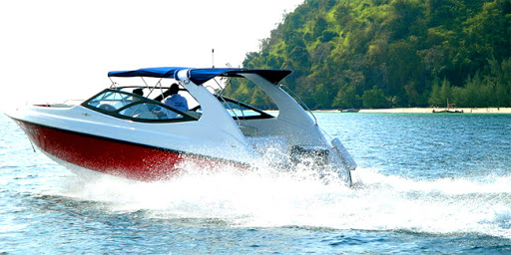
Krabi One Day Tour To Hong Islands By Speed Boat
( Adult 1,300 Baht/Person Child 1,100 Baht/person

Time: 09.00am. – 03.00 pm.
- 08.30 am Pick up from Hotel to the pier.
- 09.00 am Transfer to Hong Islands passing by the Royal Palace and Klong Muang at located in Klong Muang.
  - Sightseeing at of Hong’s "room" lagoon inside the island, with high towers of limestone cliffs on all sides.
  - Hong Island - National Park office, fantastic white powder sands, sun and shade, picnic tables and toilets facilities, ideal place for lunch.
  - Pakbia Island - two of Hong’s archipelago with unspoiled beauty and opportunities for swimming and sunbathing.
- 03.00 pm Back to the pier transfer to hotel

Tour Itinerary
Include : Mask & Snorkel, Life jacket, Lunch, Fruits & water, Experienced guide, National park entrance fee,Insurance, Hotel transfers
Exclusions :
- Optional tours or excursions not mentioned in the program
- Other meals not mentioned in the program
- Personal expenses
- Services change 3.5% pay by credit cards

Remark
- Operate high season only
- This program is subject to change according to the weather and sea conditions
*PRICE AND ITINERARY ARE SUBJECT TO CHANGE WITHOUT PRIOR NOTICE*

