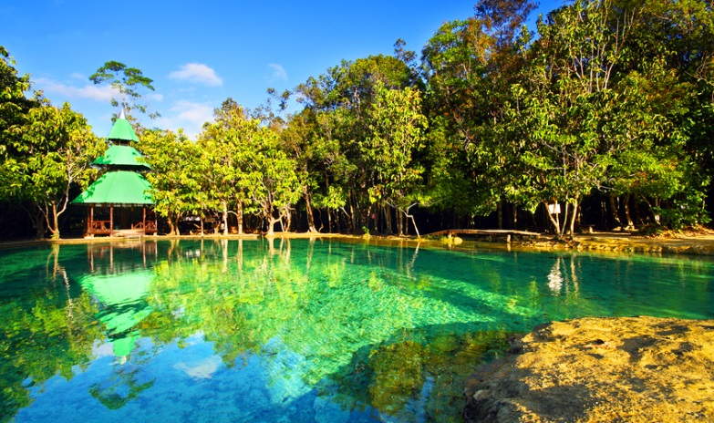
Krabi Jungle Tour Hot Spring & Emerald Pond
( Adult 1,200 Baht/Person Child 900 Baht/person )

Time: 08.30 am. – 04.00 pm.
08.30 am. Pick you up from hotel’s lobby.
09.45 am. Arrive at Hot Spring relax in the unseen juggle bathtub with temperature about 40 - 50 the degree Celsius .Aside from the hot springs there are hot water pools which make like spa system, good for relaxing
12.00 am. Have lunch in a restaurant in front of Crystal pool‘s entrance
01.00 pm. Start hiking into the rain forest which many natural springs and pools along. The largest pool called “Emerald Pond” never dries up.
02.30 pm. We will visit Tiger Cave,which was inhabited by the last tiger of Krabi, is now a Buddhist temple famous for meditation.
04.00 pm. Transfer back to your hotel.

Tour Itinerary
Include : Lunch, Life jacket, Fruit, Drinking water, Insurance, Dry bag, Coffee, Tea, Soft drink, Tour guide license

Exclusions :
- Optional tours or excursions not mentioned in the program
- Other meals not mentioned in the program
- Personal expenses
- Services change 3.5% pay by credit cards
Please bring : Sunglasses, sun-lotion, camera, dry clothes to change.
Remark
- Operate high season only.
- This program is subject to change according to the weather and sea conditions.
*PRICE AND ITINERARY ARE SUBJECT TO CHANGE WITHOUT PRIOR NOTICE*

