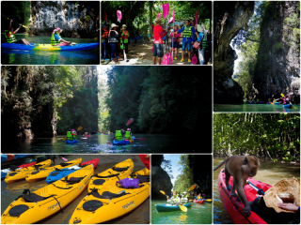
Krabi Half Day Tour Kayaking At Ao Thalane
( Adult 700 Baht/Person Child 500 Baht/person )

08.30 am. Pick up at the hotel.
09.00 - 09.45 am. Departure from Aonang to Ao Thalane
Welcome you to the friendly trip of Ao Thalane. The fascinating of canyon will make you satisfy. You will enjoy with padding in the area of sea any mangrove. Tow atmosphere of sea kayaking and mangrove forest. Kayaking make fun. You will more to learn with the abundant of mangrove area and sand bank when the level of tidy lows.
Enjoyable with many kinds of animals like monkey, mud keeper, crabs and shells this trip you will get fun to see canyon, lagoon, and limestone historical painting.

Tour Itinerary
Include : Hotel transfers, Life Jacket, Dry bag, Lunch, soft drinks, Professional guide, Insurance
Exclusions :
- Optional tours or excursions not mentioned in the program
- Other meals not mentioned in the program
- Personal expenses
- Services change 3.5% pay by credit cards
Please bring : Sunglasses, sun-lotion, camera, dry clothes to change.

Remark :
- Operate high season only
- This program is subject to change according to the weather and sea conditions
*PRICE AND ITINERARY ARE SUBJECT TO CHANGE WITHOUT PRIOR NOTICE*

