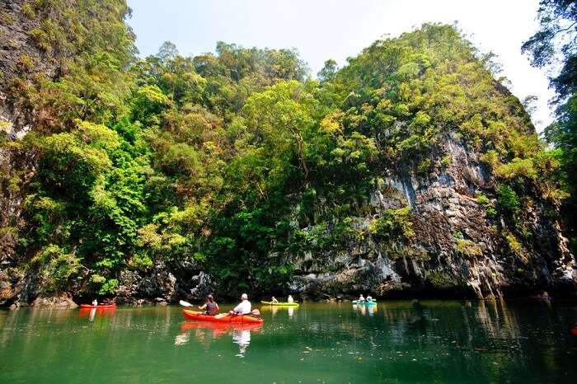
Krabi Full Day Kayaking At Bor Thor Village
( Adult 1,500 Baht/Person Child 900 Baht/person )

Full day trip 08.30 a.m. - 04.30 p.m.
- Pick up from your hotel.
- Transfer to Bor Thor village by minivan
- The trip takes about 40 minutes with paddling through the magnificent mangrove forest
- Paddle to Them Lod Tai - a cave tunnel under the limestone mountain where many splendid stalactites guards the entrance.
- Paddle to reach Tham Pee Hua Toh - a big airy cave where there're several prehistoric paintings on the wall as well as layers of archeological shell formations.
- Paddle to Them Khao Wong cave - a gorgeous inner lagoon.
Tour Itinerary
Include : Lunch, Life jacket, Fruit, Drinking water, Insurance, Dry bag, Coffee, Tea, Soft drinks, Licensed tour guide.
Exclusions :
- Optional tours or excursions not mentioned in the program
- Other meals not mentioned in the program
- Personal expenses
- Services change 3.5% pay by credit cards
Please Bring : Sunglasses, sun-lotion, camera, dry clothes to change.
Remark
- Operate high season only
- This program is subject to change according to the weather and sea conditions.
*PRICE AND ITINERARY ARE SUBJECT TO CHANGE WITHOUT PRIOR NOTICE*

