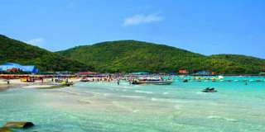
Coral Island
A little way off Pattaya, there 3 slams islands well known for their powdery sand, colorful corals and other forms life under the sea, which can be viewed conveniently from the glass-bottomed boats
Daily : Pick up time 10.30 a.m. From Pattaya beach
Price : 1,100.- baht
Note : Incl. Lunch by Speed Boat.
All price are subject to change without prior notice and may surcharge for stay over major holiday

