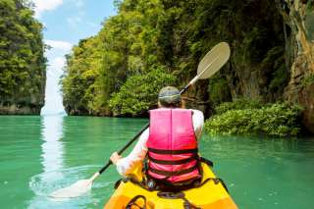

Time : 08:30 a.m. – 03:30 p.m.
Pick up from your hotel
Arrive at Thung Yi Peng Pier
Experience the nature of Thung Yi Peng Village (Mangrove Forest)
Monkey watching monkeys eat bananas ( long-tail boat ride )
Take a long-tail boat to Talabeng Island.
Start kayaking around Talabeng Island.
Explore Talabeng Sea Caves
Take a long-tail boat to Bubu Island for lunch.
Swim, sunbathe, relax at Bubu Island
back to Koh Lanta
Transfer back to your hotel

