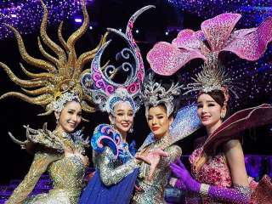
Tiffany Show
Tiffany’s Show is recognized as the first transvestite cabaret show in South East Asia with more than 30 years of experience. The 1 hour 15 minute long show is an explosion of light and sound. Tiffany’s Show has fantastic sets and dazzling costumes and the most beautiful "showgirls" in Asia. Tiffany's Show is the stage experience of a lifetime and was voted among the world’s top 10 most entertainment show by "Travel come Magazine"

Daily : Show 06.30 p.m. and 08.00 p.m. and 09.30 p.m.
Price : V.I.P Seat 1,300.-Baht
Normal Seat 1,100.- Baht
All price are subject to change without prior notice and may surcharge for stay over major holiday

