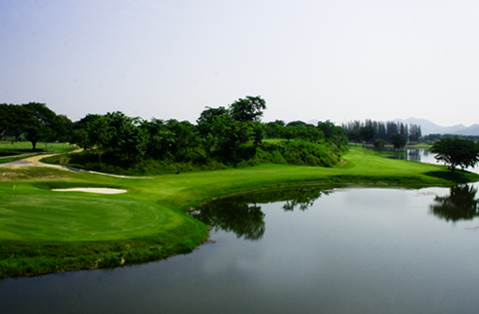
Golf Tour Package Itinerary For The River Kwai Golf History Week

This golf tour package can be customized according to your preferences.
Day 1 - Arrival in Bangkok & Transfer to Kanchanaburi
Arrival Bangkok's Suvarnabhumi Airport and transfer to River Kwai.
Day 2 - Golf at Blue Sapphire Golf Club
Golf at Blue Sapphire Golf Club (tough course with lots of water and tricky holes).
Day 3 - Golf at Mission Hills Golf Club Kanchanaburi
Golf at Mission Hills Golf Club Kanchanaburi (challenging Nicklaus design; beautiful surroundings).
Day 4 - Sightseeing
Best of River Kwai sightseeing tour including 'Bridge Over The River Kwai', Jeath War Museum, Hell Fire Pass, and local markets.
Day 5 - Golf at Nichigo Golf Resort & Country Club
Golf at Nichigo Golf Resort & Country Club (area's most popular course, scenic and interesting design).
Day 6 - Golf at Royal Ratchaburi Golf Club
Golf at Royal Ratchaburi Golf Club (hilly and scenic course is a hidden gem [watch for the monkeys]).
Day 7 - Departure
Transfer to Bangkok's Suvarnabhumi Airport for departure.

Start Location : River Kwai Kanchanaburi
Tour Length : 7 Days (Length can be adjusted)
Price From : 27,600
All accommodations
Inclusions :
- Daily breakfast
- All green fees
- 1 caddy per golfer at each golf course
- All airport, land, and golf course transfers
- All transfers by private VIP high roof touring van
- Local knowledge, expertise, suggestions, and support throughout trip
- 24/7 golf hotline staffed by knowledgeable service personnel
- All taxes and service charges
Exclusions :
- International airfare
- Personal items, drinks, and gratuities
Recommended Hotels :
- 4 Star Felix River Kwai Hotel
- We have a wide range of 3 - 5 star hotels available. To meet your preferences and budget please contact us for further information.

