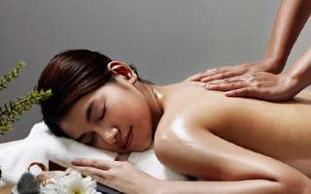

Golf Tour Package Itinerary for the Koh Samui Golf & Spa Package

This golf tour package can be customized according to your preferences.
Day 1 - Arrival in Koh Samui
Arrival Koh Samui airport and transfer to hotel.
Day 2 - Golf at Santiburi Samui Country Club
Golf at Santiburi Samui Country Club (one of Thailand's most spectacular courses).
Day 3 - Spa & Massage Treatment
Half day spa and massage treatment.
Day 4 - Departure
Transfer to Koh Samui airport for departure.

Start Location : Koh Samui
Tour Length : 4 Days (Length can be adjusted)
Price from : 13,950

Inclusions :
- All accommodations
- Daily breakfast
- All green fees
- 1 caddy per golfer at each golf course
- All airport and golf transfers
- All transfers by VIP touring van
- Local knowledge, support, and expertise throughout trip
- 24/7 golf hotline staffed by knowledgeable personnel
- All taxes and service charges
Exclusions :
- International airfare
- Personal items, drinks, and gratuities
Recommended Hotels :
- 4 Star Amarin Victoria Resort Samui
- 4 Star Mercure Samui Buri Hotel
- 4 Star Imperial Boat House Hotel Samui
- 5 Star Bo Phut Resort & Spa
- We have a wide range of 3 - 5 star hotels available. To meet your preferences and budget please contact us for further information.

