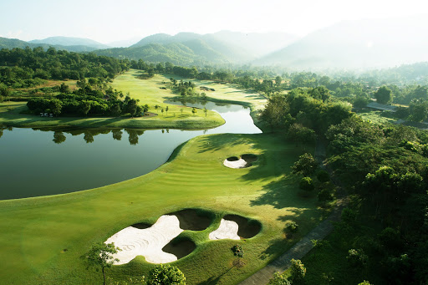
Golf Tour Package Itinerary for the Chiang Mai - Chiang Rai Golf Package

This golf tour package can be customized according to your preferences.
Day 1 - Arrival in Chiang Mai
Arrival Chiang Mai airport and transfer to hotel.
Day 2 - Golf at Royal Chiang Mai Golf Club & Resort
Golf at Royal Chiang Mai Golf Club & Resort (enjoyable Peter Thomson course in scenic countryside).
Day 3 - Golf at Chiang Mai Highlands Golf and Spa Resort
Golf at Chiang Mai Highlands Golf and Spa Resort (#1 course in Chiang Mai; highly recommended).
Day 4 - Golf at Alpine Golf Resort Chiang Mai
Golf at Alpine Golf Resort Chiang Mai (site of 2013/4 Asian Tour events is best conditioned Chiang Mai course).
Day 5 - Transfer To Chiang Rai & Golf at Santiburi Chiang Rai Country Club
Transfer to Chiang Rai. Golf at Santiburi Chiang Rai Country Club (beautiful Robert Trent Jones Jr. course is one of the north's best).
Day 6 - Golf at Waterford Valley Golf Club & Resort
Golf at Waterford Valley Golf Club & Resort (well designed hilly, challenging and scenic course).
Day 7 - Departure
Transfer to Chiang Rai airport for departure.

Start Location : Chiang Mai
Tour Length : 7 Days (Length can be adjusted)
Price from : 22,130

Inclusions :
- All accommodations
- Daily breakfast
- All green fees
- 1 caddy per golfer at each golf course
- All airport, land, and golf course transfers
- All transfers by private VIP high roof touring van
- 24/7 golf hotline staffed by knowledgeable service personnel
- All taxes and service charges
Exclusions :
- International airfare
- Personal items, drinks, and gratuities
Recommended Hotels :
- 3 Star Duangtawan Hotel Chiang Mai
- 3 Star Wangcome Hotel Chiang Rai
- 4 Star Rimping Village Chiang Mai Hotel
- 4 Star The Legend Chiang Rai Boutique River Resort & Spa
- 5 Star Anantara Chiang Mai Resort & Spa
- We have a wide range of 3 - 5 star hotels available. To meet your preferences and budget please contact us for further information.
Extra Info : This Northern Thailand Golf Package can start in either Chiang Mai or Chiang Rai.

