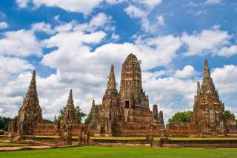
Ayuttaya 1 Day by Bus + Boat (0730 -1600 Hrs)
(1,900.- Baht / Person)
Itinerary
07:15HRS | Check in River City – Counter No.2 To Embark “Grand Pearl Coach”.
07:30HRS | Depart Bangkok by air-conditioned coach visit Ayutthaya Ancient Capital.
09:00HRS | Arrive Bang Pa-In Summer Palace , previously lived by many Thai monarchs from 17 th century. Bang Pa-In has a captivating collection of marvelous pavilions in a variety of Thai, Chinese, Italian and Victorian architectural styles, encircled by lush beautiful gardens and lake.
10:45HRS | Arrive Ayutthaya one of the world heritage cities. Visit Viharn Phra Monkol Bopit The principal Buddha image is one of Thailand 's largest bronze.
11:15HRS | Visit Wat Phrasrisanphet , This is the most important temple within the Royal Palace compound and corresponds to The Emerald Buddha Temple in Bangkok's Grand Palace
12:15HRS | Wat Chai Wattanaram constructed by King Prasathong in 1630.
13:30HRS | Welcome onboard the luxurious cruiser “Grand Pearl” at Wat Chonglom ( Nualchawi Bridge ) Super buffet lunch which includes a delightful variety of oriental and western cuisines will be served. In the meantime, you will relax and enjoy the fascinating scenery on the River of Kings .
15:00HRS | Coffee break will be served while you enjoy the enchanting sight along the river banks such as the Royal Barges, Thammasart University , the Royal Grand Palace and the graceful Temple Of Dawn .
16:00HRS | Arrive at the River City Shopping Complex Pier.
Inclusions : A joined roundtrip air-conditioned transportation (BKK-Ayutthaya), Admission fee to all places indicated in the program, Lunch, A join cruise, English speaking guide.
Price exclude:
- Personal Expense
- Service charge 3.5% for paying by credit card charge

PRICE AND ITINERARY ARE SUBJECT TO CHANGE WITHOUT PRIOR NOTICE

