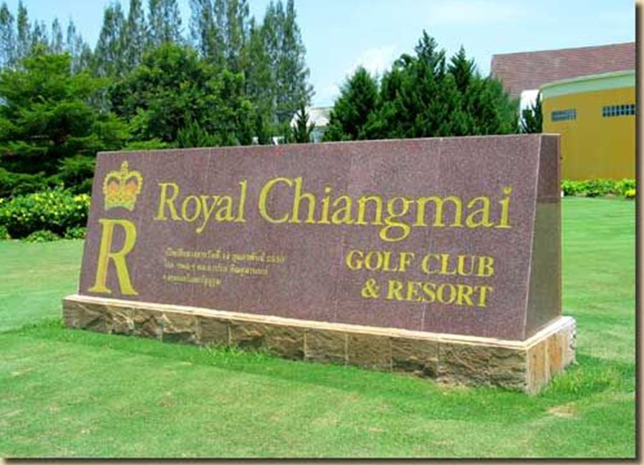
Golf Tour Package Itinerary for the Northern Thailand Golf & Culture Holiday

This golf tour package can be customized according to your preferences.
Day 1 - Arrival in Chiang Mai
Arrival Chiang Mai Airport and transfer to hotel.
Day 2 - Golf at Royal Chiang Mai Golf Club & Resort
Golf at Royal Chiang Mai Golf Club & Resort (enjoyable Peter Thomson course in scenic countryside).
Day 3 - Full Day Chiang Mai HighlightsTour
Journey to the top of Thailand’s tallest mountain visit Doi Inthanon National Park. Along the way stop at the King and Queen’s twin pagodas, see one of Thailand’s most impressive waterfalls, and visit hill tribe villages.
Day 4 - Golf at Alpine Golf Resort Chiang Mai
Golf at Alpine Golf Resort Chiang Mai (site of 2013/4 Asian Tour events is best conditioned Chiang Mai course).
Day 5 - Golf at Chiang Mai Highlands Golf and Spa Resort
Golf at Chiang Mai Highlands Golf and Spa Resort (#1 course in Chiang Mai; highly recommended).
Day 6 - Scenic Transfer to Chiang Rai
Journey overland through the Northern Mountains and by river to Chiang Rai.
Day 7 - Golf at Waterford Valley Golf Club & Resort
Golf at Waterford Valley Golf Club & Resort (well designed hilly, challenging and scenic course).
Day 8 - Full day Golden Triangle Tour
Visit the 700 year old city of Chiang Seanr to view archeological sites on the Laotian border. Then see the notoriousGolden Triangle, Opium Museum, and view Thailand, Myanmar, and Laos from a single vantage point.
Day 9 - Golf at Santiburi Chiang Rai Country Club
Golf at Santiburi Chiang Rai Country Club (beautiful Robert Trent Jones Jr. course is #1 in Chiang Rai).
Day 10 - Departure
Transfer to Chiang Rai airport for departure

Start Location : Chiang Mai
Tour Length : 10 Days (Length can be adjusted)
Price from : 35,850

Inclusions :
- All accommodations
- Daily breakfast
- All green fees
- 1 caddy per golfer at each golf course
- All sightseeing tours and admission charges
- All airport, land, and golf course transfers
- All transfers by VIP high roof touring van
- 24/7 golf hotline staffed by knowledgeable service personnel
- All taxes and service charges
Exclusions :
- International airfare
- Personal items, drinks, and gratuities
Recommended Hotels :
- 3 Star Wangcome Hotel Chiang Rai
- 3 Star Duangtawan Hotel Chiang Mai
- 4 Star Rimping Village Chiang Mai Hotel
- 4 Star The Legend Chiang Rai Boutique River Resort & Spa
- 5 Star Le Meridien Chiang Rai Resort
- 5 Star Anantara Chiang Mai Resort & Spa
- We have a wide range of 3 - 5 star hotels available. To meet your preferences and budget please contact us for further information.
Extra Info
- Non-golfers welcome at special prices.

