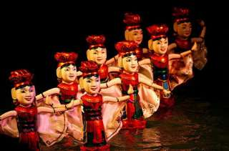
Water Puppetry Show
Water Puppetry has been a traditional performing art in Vietnam for centuries. Indeed, an inscription at Doi pagoda in Nam Ha province dates back to 1221 stating that the first water puppet show was staged there in honor of the Kings longevity.
Originally Vietnamese peasants were creators of this performing art to celebrate agricultural festivals such as spring time and harvest.
The French said of this performing art ; "it is the soul of the Vietnamese, with a create inverness and sensitivity Water Puppetry holds rank among the most important forms of puppet theater"
Water gives breath to the puppet figures and becomes itself a character of the show. The water surface gently undulating with a flock of swimming ducks romanticizes the illusory veil of smoke as group of fairies land to dance and celebrate. Then it can change dramatically becoming a seething fury as dragons do battle.
Imagine the romantic scenery of pastoral Asia through this artistic gentleness, where land, water, green trees, clouds, wind, fire and smoke are present reflecting a perfect harmony between art, humanity and nature.
Daily : Show time 07.45 p.m. and 09.00 p.m.
Price : Show only Adult 800.- baht
Show only Child 550.- Baht
Note : Child 2-11 yrs.

All price are subject to change without prior notice and may surcharge for stay over major holiday

