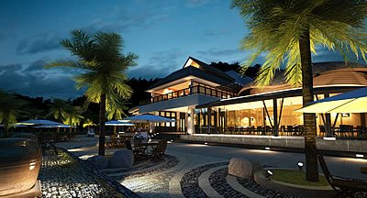
Golf Tour Package Itinerary for the Complete Hua Hin Golf Vacation

This golf tour package can be customized according to your preferences.
Day 1 - Arrival
Arrival Bangkok Suvarnabhumi Airport and transfer to Hua Hin.
Day 2 - Golf at Majestic Creek Country Club
Golf at Majestic Creek Country Club (excellent layout in hills west of Hua Hin).
Day 3 - Golf at Imperial Lake View Resort & Golf Club
Golf at Imperial Lake View Resort & Golf Club (strong parkland layout; 2015 Asian Tour Q-school venue).
Day 4 - Free
Today will be free at your own leisure.
Day 5 - Golf at Sea Pines Golf Course
Golf at Sea Pines Golf Course (exciting links-style course on the Gulf of Thailand).
Day 6 - Golf at Springfield Royal Country Club
Golf at Springfield Royal Country Club (Nicklaus design is a long time area favorite).
Day 7 - Free
Today will be free at your own leisure.
Day 8 - Golf at Black Mountain Golf Club
Golf at Black Mountain Golf Club (1st class European Tour & Royal Trophy venue).
Day 9 - Golf at Banyan Golf Club
Golf at Banyan Golf Club (2009 Best New Course In Asia: scenic & challenging).
Day 10 - Departure
Transfer to Bangkok Suvarnabhumi Airport for departure.

Start Location : Hua Hin
Tour Length : 10 Days (Length can be adjusted)
Price from : 43,690

Inclusions :
- All accommodations
- Daily breakfast
- All green fees
- 1 caddie per golfer at each golf course
- All airport, land, and golf course transfers
- Transfers by private VIP high roof touring van or equivalent
- Local knowledge, expertise, suggestions, and support throughout trip
- 24/7 golf hotline staffed by knowledgeable service personnel
- All taxes and service charges
Exclusions :
- International airfare
- Personal items, drinks, and gratuities
Recommended Hotels :
- 3 Star Wannara Hotel Resort and Spa, Hua Hin
- 4 Star Amari Hua Hin
- 5 Star Anantara Hua Hin Resort & Spa
- We have a wide range of 3 - 5 star hotels available. To meet your preferences and budget please contact us for further information.
Extra Info : This Hua Hin golf package can be extended or combined with a Bangkok or any other destination to make your Thailand golf vacation even more complete.

