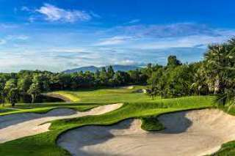
Golf Tour Package Itinerary for the 3 Rounds Bangkok Golf Package

This golf tour package can be customized according to your preferences.
Day 1 - Arrival & Golf At Muang Kaew Golf Club
Arrival Bangkok's Suvarnabhumi Airport. Golf at Muang Kaew Golf Club (well maintained course with good variety is testing though enjoyable for all).Transfer to hotel.
Day 2 - Golf at Pinehurst Golf & Country Club
Golf at Pinehurst Golf & Country Club (host of 1992 Johnnie Walker Classic & 1994 Thailand Open).
Day 3 - Golf at Legacy Golf Club
Golf at Legacy Golf Club (challenging Nicklaus design formerly known as Natural Park Ramindra).
Day 4 - Departure
Transfer to Bangkok's Suvarnabhumi Airport for departure.

Start Location : Bangkok
Tour Length : 4 Days (Length can be adjusted)
Price from : 15,250
Inclusions :
- All accommodations
- Daily breakfast
- 1 caddie per golfer at each golf course
- All airport transfers
- All golf course transfers
- All transfers by Private VIP high roof touring van or equivalent
- 24/7 golf hotline staffed by knowledgeable service personnel
- All taxes and service charges
Exclusions :
- International airfare
- Personal items, drinks, and gratuities
Recommended Hotels :
- 3 Star The Palazzo, Bangkok
- 4 Star Park Plaza Bangkok Soi 18
- 5 Star Sofitel So Bangkok
- We have a wide range of 3 - 5 star hotels available. To meet your preferences and budget please contact us for further information.
Extra Info : Special golf course and hotel preferences welcome.

