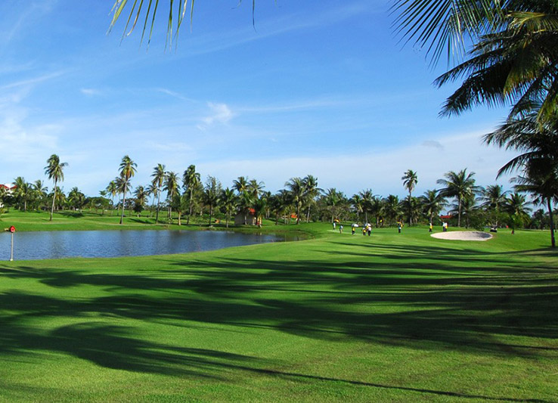
Golf Tour Package Itinerary for the One Week Pattaya Golf Holiday

This golf tour package can be customized according to your preferences.
Day 1 - Arrival in Bangkok / Transfer to Pattaya
Arrival Bangkok Suvarnabhumi Airport and transfer to your hotel.
Day 2 - Golf at Eastern Star Country Club & Resort
Golf at Eastern Star Country Club & Resort (strategic Robert Trent Jones Jr. course).
Day 3 - Golf at Khao Kheow Country Club
Golf at Khao Kheow Country Club (popular Pete Dye design).
Day 4 - Free
Free day at your own leisure.
Day 5 - Golf at Silky Oak Country Club
Golf at Silky Oak Country Club (scenic course with dramatic elevation changes).
Day 6 - Golf at Siam Country Club, Plantation Course
Golf at Siam Country Club, Plantation Course (spectacular Pattaya course is a 'must play'; site of 2009 USLPGA and 2015 Thailand Open).
Day 7 - Departure
Transfer to Bangkok Suvarnabhumi Airport for departure.

Start Location : Pattaya
Tour Length : 7 Days (Length can be adjusted)
Price from : 21,990
Inclusions :
- All accommodations
- Daily breakfast
- All green fees
- 1 caddie per golfer at each golf course
- All airport, land, and golf course transfers
- All transfers by private VIP high roof touring van or sedan
- 24/7 golf hotline staffed by knowledgeable personnel
- Local knowledge, expertise, suggestions, and support throughout trip
- All taxes and service charges
Exclusions :
- International airfare
- Personal items, drinks, and gratuities
Recommended Hotels :
- 3 Star Sabai Resort Pattaya
- 4 Star Woodlands Hotel & Resort
- 5 Star Hilton Pattaya
- We have a wide range of 3 - 5 star hotels available. To meet your preferences and budget please contact us for further information.

