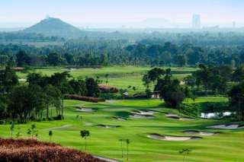
Golf Tour Package Itinerary for the Pattaya Short Golf Tour

This golf tour package can be customized according to your preferences.
Day 1 - Arrival in Bangkok / Golf At Khao Kheow Country Club / Transfer to Pattaya
Arrival Bangkok’s Suvanabhumi Airport.
Golf at Khao Kheow Country Club & Resort (challenging and popular Pete Dye design).
Transfer to Pattaya.
Day 2 - Golf at Burapha Golf Club
Golf at Burapha Golf Club (site of 2010 Thailand Open).
Day 3 - Golf at Siam Country Club, Plantation Course
Golf at Siam Country Club, Plantation Course (spectacular Pattaya course is a 'must play'; site of 2009 USLPGA and 2015 Thailand Open).
Day 4 - Golf at Laem Chabang International Country Club
Golf at Laem Chabang International Country Club (Nicklaus design is among Thailand's best).
Day 5 - Departure
Transfer to Bangkok's Suvarnabhumi Airport for departure.
Start Location : Pattaya
Tour Length : 5 Days (Length can be adjusted)
Price from : 15,800

Inclusions :
- All accommodations
- Daily breakfast
- All green fees
- 1 caddie per golfer at each golf course
- All airport, land, and golf course transfers
- All transfers by private VIP touring van
- 24/7 golf hotline staffed by knowledgeable personnel
- Local knowledge, expertise, suggestions, and support throughout trip
- All taxes and service charges
Exclusions :
- International airfare
- Personal items, drinks, and gratuities
Recommended Hotels :
- 3 Star Areca Lodge
- 4 Star Page 10 Hotel Pattaya
- 5 Star Centara Grand Phratamnak Resort Pattaya
- We have a wide range of 3 - 5 star hotels available. To meet your preferences and budget please contact us for further information.

