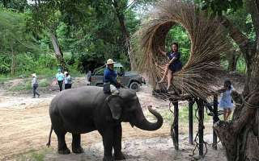
Pattaya Elephant Village

Pattaya Elephant Village is located at km. 145 of Sukhumwit Road. Shows are staged in which you will see elephants displaying forestry skills, playing football, and a parade of elephants decorated with ancient battle gear. The village also demonstrates how wild elephants are captured in the northeastern part of Thailand. Elephant rides to the nearby woods are also available at 10.30 a.m. and 04.30 p.m.
Daily : Pick up time 01.30 p.m.
(Half day tour)
Price :
Adult 1,200.- Baht
Child 1,000.- Baht
All price are subject to change without prior notice and may surcharge for stay over major holiday

