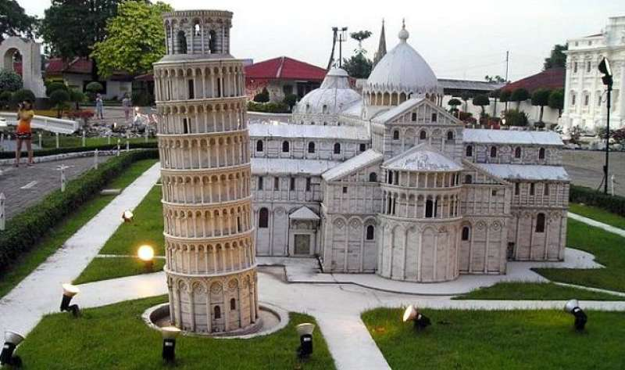

Mini Siam & Mini Europe

Located near Central Pattaya at km. 143 of Sukhumwit Road, it is Thailand's first wonder displaying Thai and European heritage on a miniature scale.
This is the third miniature town in the world built after those in the Netherlands and Taiwan that brings together models of important objects and historical sites of different cultures and civilizations of various periods from the ancient time till present. More than 100 models, each on a scale of 1:25, are displayed in an area of 29 rai, surrounded by natural setting.
Daily : Pick up time 09.00 a.m. and 12.30 a.m.
Price : 1,200.- Baht (Minimum 2 pax)
All price are subject to change without prior notice and may surcharge for stay over major holiday

