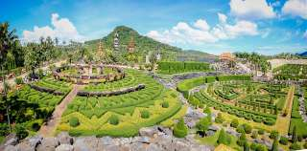
Nong Nooch Garden
about 18 kilometers from South Pattaya, is a Thai-village-style recreational park. The entire area of some 500 acres is beautifully landscaped with an orchid nursery and other botanical gardens. There are also cultural and tradition performances and an elephant show.
Daily : Pick up time 08.30 a.m. and 01.30 p.m.
Price / Half Day : Adult 1,300.- Baht
Child 1,000.- Baht
Price / Full Day : Adult 1,800.- Baht
Child 1,300.- Baht (Show + Lunch)
Note : Child 2-11 yrs.
All price are subject to change without prior notice and may surcharge for stay over major holiday

