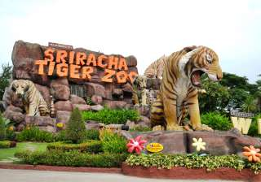
Sriracha Tiger Zoo
Located off Route 3241 in Si Racha County north of Pattaya City, only 30 min. drive from Pattaya. The greatest tiger zoo in a natural atmosphere where you can hold, feed and take photos with baby tigers. Watch a sow breast-feeding tiger cubs. See how tigers, pigs and dogs live together peacefully. View a large number of scorpions on ladies' bodies. Witness a crocodile wrestling show by lady performers.
Price:
Half Day Tour : 800.- Baht
Full Day Tour : 1500.- Baht
All price are subject to change without prior notice and may surcharge for stay over major holiday

